3 Way Air Freshener Dispenser
Donny H. Stephens II & Michael Firestone
Computer and Electrical Engineering Undergrads

Abstract
In this report we will start by discussing some background aspects of the microcontroller and our project. Then we will discuss the specifications and schematic of our project. After that we will go into our results including some photos of the code etc. From there we will discuss what went correctly during our project, what went wrong and what we would’ve done differently. Finally, we will conclude our project.

3 Way Air Freshener Dispenser
Our goal during this project is to implement a stimulation of an air freshener with three different functions. One function of the air freshener is short() which disperse the spray from the air freshener for a duration of 5 seconds. The second function is medium() which disperse the spray from the air freshener for a duration of 10 seconds. The third function is long() which disperse the spray from the air freshener for a duration of 15 seconds.

Back Ground
Msp430 Microprocessor helps aid the formatting changes of Analogue to digital conversions. An Input frequency is sent through the chip at continuous time and then is converted to discrete time thus sampling a time period as 2T>T. This conversion is represented by analog X(t)=Acos(2πωt+φ)→Discrete time X[n]=Acos(2πfn/fs+φ).

Project Background
An Air Freshener is simulated using an msp430 microcontroller. Timers and low power modes are used to instruct msp430 use. It will behave as an autonomous Air freshener dispenser. Three programs known as short, medium, and long are used to simulate the air freshener. Therefor real world applications of a microcontroller are utilized

System Specifications:
Short() mode should spray fragrance for 5 seconds. Medium() mode should spray fragrance for 10 seconds. Long() mode sprays for 15 seconds. 3 LED’s will be in place of spray). Push buttons will act as an instant spray On/Off system, warning LED lights up right before spray is dispense. When the system is off All LED’s are off and system is in low power mode. When system is on LEDs are powered and ready to be dispensed.

Schematic:
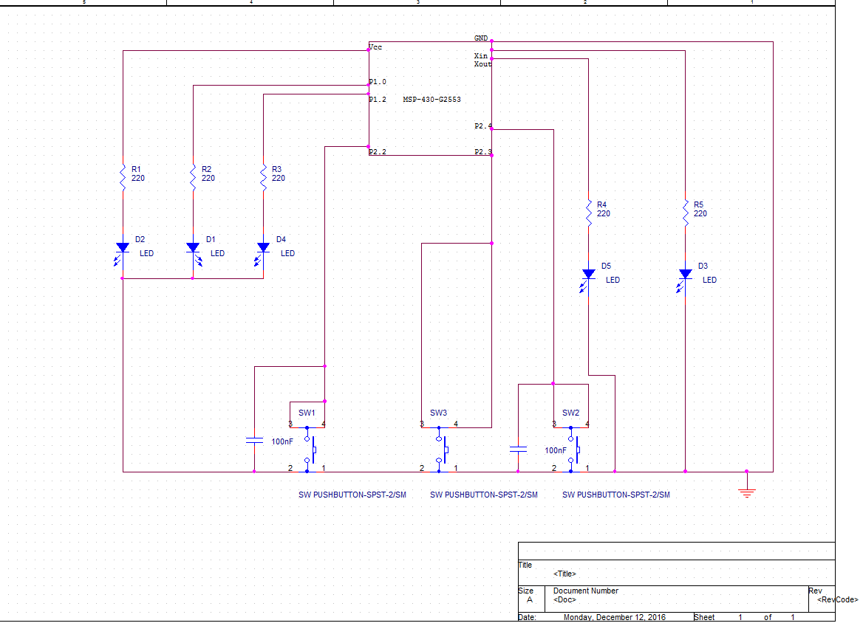 (Firestone, 2016)

Results:.
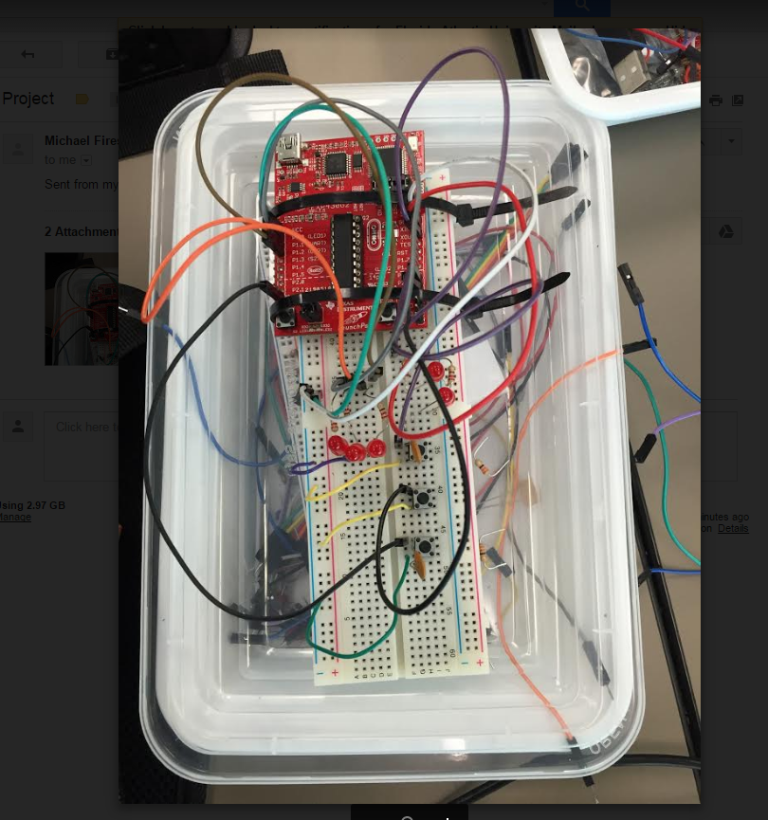
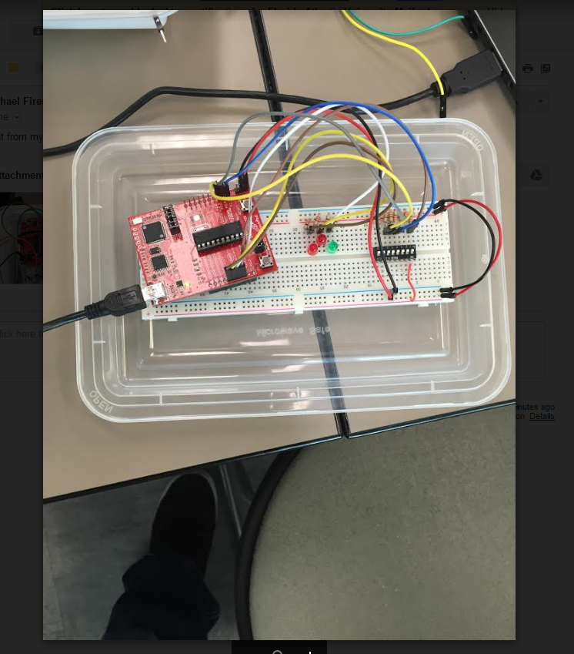
Our results were not exactly what we were looking for. The Air freshener simulation turns on properly powering the 3 LEDs. The board doesn’t toggle the 3 different functions on its own but instead the 3 existing LEDs work directly with corresponding switches.

Discussion:
During our project the initial board didn’t have enough room for everything to fit nicely. Also we had trouble implementing the code for the push buttons therefore we resorted to assembling a different board and attempting a different approach to accomplishing the goal.

Conclusion:
In conclusion, although our results weren’t what we wanted. We did learn a lot doing it and by trial and error we learned different approaches to trouble shooting codes and the board.

References
Last Name, F. M. (Year). Article Title. Journal Title, Pages From - To.
Last Name, F. M. (Year). Book Title. City Name: Publisher Name.

Footnotes
1[Add footnotes, if any, on their own page following references. For APA formatting requirements, it’s easy to just type your own footnote references and notes. To format a footnote reference, select the number and then, on the Home tab, in the Styles gallery, click Footnote Reference. The body of a footnote, such as this example, uses the Normal text style. (Note: If you delete this sample footnote, don’t forget to delete its in-text reference as well. That’s at the end of the sample Heading 2 paragraph on the first page of body content in this template.)]

Tables
Table 1
[Table Title]
Column Head | Column Head | Column Head | Column Head | Column Head
Row Head | 123 | 123 | 123 | 123
Row Head | 456 | 456 | 456 | 456
Row Head | 789 | 789 | 789 | 789
Row Head | 123 | 123 | 123 | 123
Row Head | 456 | 456 | 456 | 456
Row Head | 789 | 789 | 789 | 789
Note: [Place all tables for your paper in a tables section, following references (and, if applicable, footnotes). Start a new page for each table, include a table number and table title for each, as shown on this page. All explanatory text appears in a table note that follows the table, such as this one. Use the Table/Figure style, available on the Home tab, in the Styles gallery, to get the spacing between table and note. Tables in APA format can use single or 1.5 line spacing. Include a heading for every row and column, even if the content seems obvious. A default table style has been setup for this template that fits APA guidelines. To insert a table, on the Insert tab, click Table.]

Figures title:

Figure 1. [Include all figures in their own section, following references (and footnotes and tables, if applicable). Include a numbered caption for each figure. Use the Table/Figure style for easy spacing between figure and caption.]
For more information about all elements of APA formatting, please consult the APA Style Manual, 6th Edition.

